**Supervised Classification**

**Corona-Virus Tweet Analysis**

By – Sneha Raikar

**ABSTRACT**

In machine learning, a fundamental challenge is the analysis of data to identify feelings using algorithms that allow us to determine the positive or negative emotions that people have regarding a topic. Social networks and micro blogging are a valuable source of information, being mostly used to express personal points of view and thoughts. Based on this knowledge we propose a sentiment analysis of English tweets during the pandemic COVID-19 in 2020. The tweets were classified as positive or negative by applying the Logistic Regression algorithm, using this method we got a classification accuracy of approx. 90+ %.

**PROBLEM STATEMENT**

The diseases that currently affect the world, especially which are classified as pandemic, cause serious problems to the population at all levels: economic, emotional, status, planning, politics, etc., in addition to the complexity of traditions, ethics, individual psychology and social behaviour of people. Therefore, it is required and necessary a people's attitudes analysis when adverse situations arise Identifying people's reaction to this threat can provide important information on how society behaves and reacts to unwanted and unexpected situations, which can be positive or negative, currently the Internet and social networks have become powerful tools to access people’s opinions and comments on various topics

The main objective is to make a predictive model, which could help in predicting the Sentiment of a tweets.

**ATTRIBUTE INFORMATION**

* Location
* Tweet at
* Original Tweet
* Sentiments

**INTRODUCTION**

Among the most common viral infections that affect humans are the respiratory infections, which are caused by Human Respiratory Viruses (RVs) The best-known type of respiratory viral infection is the influenza or "flu", and every year causes between 250,000 and 500,000 deaths worldwide, being the H1N1 virus the most well-known variant One of the family of viruses that causes respiratory diseases is the corona virus, which in humans infects the epithelial cells of the respiratory tract, being sometimes unnoticeable, but in some cases deadly, and can even affect other mammals and birds. There are several types of corona viruses, the best-known are The Middle East Respiratory Syndrome (MERS), the severe acute respiratory syndrome (SARS) and nowadays the Corona virus Disease (COVID-19).

The first cases of people having symptoms of infection in the respiratory tract caused by corona virus occurred in mid-December, 2019.On December31,2019, the Wuhan Health Commission published information on cases about atypical pneumonia affecting patients coming from a local market in the city of Wuhan - China. By late February, 2020, more than 4500 cases and more than 60 deaths related to COVID-19 had been confirmed outside of China. On March 11, 2020, approximately 118,000 people were infected in 114 countries and 4,291 deaths had been confirmed, due to these alarming levels of severity and spread of corona virus the World Health Organization (WHO) declared the COVID-19 disease as a pandemic.

The first COVID-19 impact analysis on humans revealed the severity of the infection. Among 67 patients, 3 (4.5%) were mild, 35 (52.2%) were moderate, 22 (32.8%) were severe and 7 (10.4%) were critically ill. The technique used to determine the severity level of the disease was the computerized tomography (CT)

The use of machine learning techniques for the search of feelings contained in a text expressed in micro blogging social networks is a fundamental point to understand people's perception of the impact that the COVID-19 pandemic has had at social, economic, political and technological levels. Based on the monthly analysis of English tweets since the beginning of the pandemic, the following article is presented

**STEPS INVOLVED**

In order to go ahead for data visualization upon key factors we need to go for certain extra steps before proceeding to the main segment. In this part we are going with the following steps:

1. Importing Analytical necessary library classes for future analysis.
2. Reading the csv data file from Google drive.
3. Setting figure size for future visualization.
4. Removing future warnings in seaborne plots.
5. Visualizing all the columns of the respective Data frame.
6. Viewing all data information
7. Checking the Unique values in the column (if any)
8. Converting the data types to similar objects as the Analysis Demands.
9. Formatting the “size” column into a single column in the dataset.
10. Eradicating special characters from the dataset columns.

* **EXPLORATORY DATA ANALYSIS**

Exploratory Data Analysis refers to the critical process of performing initial investigations on data so as to discover patterns, to spot anomalies, to test hypotheses and to check assumptions with the help of summary statistics and graphical representations. It gives us better idea of which feature behaves in which manner compared to target variable. After loading the dataset, we performed this method by comparing our target variable that is Rented Bike count with other independent variables. This process helped us figuring out various aspects and relationships among the target and the independent variables.

* **EXAMINING** **NULL** VALUES

The most critical thing from which we can draw some observations is Dataset, however data comes with unexpected values too i.e., sometimes it may be Null or missing in other words the space might be blank. Thus, at the time of analysing the first thing which we will do is to examine the null or missing values on the Dataset. It is the first step that will make the results “more” accurate &should be handled before it affects the performance of the models that predict the outcome.

* **NATURAL LANGUAGE PROCESSING**

The difference between text mining and natural language processing must be considered. Text mining focuses on the discovery and extraction of information of interest within an unstructured text, whereas natural language processing aims to perform an extraction of a more complete meaning indicator from a text, trying to find out who, when, where, how and why an action was performed, to achieve it, NLP applies complex algorithms to perform different types of analysis such as morphological and lexical, syntactic, semantic, discourse integration and pragmatic

* **Tokenizing**

TF = number of times a word appears in a document / total number of words in the document

*n*

The process of tokenization is the division of a long text into sentences which will be delimited by punctuation marks showing the end, or by words creating a list that stores all the words in a text individually.

* **STEMMING**

IDF = total number of documents / number of documents where a word is present

Stemming is the technique that identifies conjugated words and represents them in a unique way that expresses the same meaning and works with heuristics that seeks to cut out the words to standardize all conjugations and derivations. On the other hand, the Lemmatization technique applies a more complex analysis that through a word morphological analysis tries to find the base form of the conjugated words e.g. "am", "are", "is" is represented with its base form "be"

* **TF-IDF**

(Term Frequency - Inverse Document Frequency), this is a technique to quantify a word within a text, thus weights will be assigned to each one of the words, which means the importance of the word in the document, and is calculated as follows:

TF-IDF = Term Frequency (TF) * Inverse Document Frequency (IDF)

Where TF is the frequency of a word in a document, while IDF is the inverse of the number of documents where the word is present.

Each document and word have its own TF, and is given by:

The IDF measures the informativeness of a word, or how rare is to find a word in a certain number of documents:

In case a word is not contained in any document, DF will be equal to 0, as dividing by 0 is undefined, the last equation was modified, having:

IDF = log(total number of documents /(number of documents where a word is present + 1))

IDF = log(N/(DF+1))

Finally, combining the equations, it is possible to get the TF-IDF score:

**TF-IDF= (t/n) * log(N/(DF + 1))**

**FITTING DIFFERENT MODELS**

* Naive Bayes
* Stochastic Gradient Descent (SGD)
* Random Forest
* Support Vector Machine
* Logistic Regression

**ALGORITHMS**

# I. Naive Bayes

The Naive Bayes classification algorithm is a probabilistic classifier. It is based on probability models that incorporate strong independence assumptions. The independence assumptions often do not have an impact on reality. Therefore, they are considered as naive. You can derive probability models by using Bayes' theorem (credited to Thomas Bayes). Depending on the nature of the probability model, you can train the Naive Bayes algorithm in a supervised learning setting.

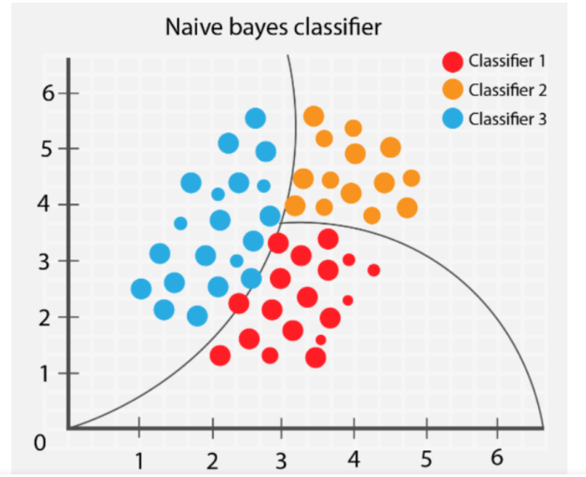

**II. Stochastic Gradient Descent**

Stochastic Gradient Descent (SGD) is a simple yet efficient optimization algorithm used to find the values of parameters/coefficients of functions that minimize a cost function. In other words, it is used for discriminative learning of linear classifiers under convex loss functions such as SVM and Logistic regression. It has been successfully applied to large-scale datasets because the update to the coefficients is performed for each training instance, rather than at the end of instances.

**III. Random Forest Classifier**

Random Forest is a bagging type of Decision Tree Algorithm that creates several decision trees from a randomly selected subset of the training set, collects the labels from these subsets and then averages the final prediction depending on the greatest number of times a label has been predicted out of all.

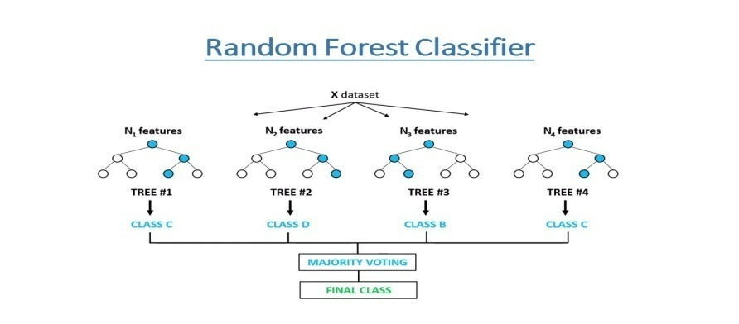

**IV. Support Vector Machine Classifier**

SVM is used mostly when the data cannot be linearly separated by logistic regression and the data has noise. This can be done by separating the data with a hyperplane at a higher order dimension.

In SVM we use the optimization algorithm as:

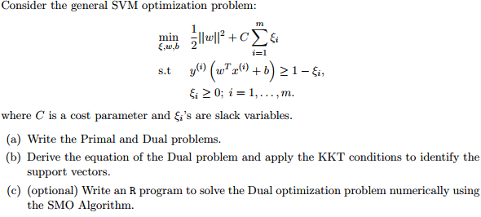

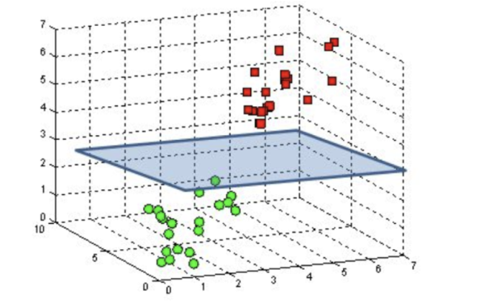

We use hinge loss to deal with the noise when the data is not linearly separable.

Kernel functions can be used to map data to higher dimensions when there is inherent non linearity.

**V.Logistic Regression**

Logistic Regression is actually a classification algorithm that was given the name regression due to the fact that the mathematical formulation is very similar to linear regression.

The function used in Logistic Regression is sigmoid function or the logistic function given by:

f(x)= 1/1+e ^(-x)

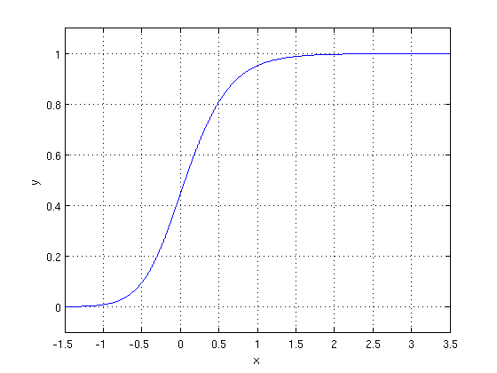

The optimization algorithm used is: Maximum Log Likelihood. We mostly take log likelihood in Logistic:

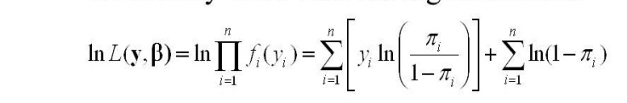

**MODEL PERFORMANCE**

**Confusion Matrix-**

The confusion matrix is a table that summarizes how successful the classification models at predicting examples belonging to various classes. One axis of the confusion matrix is the label that the model predicted, and the other axis is the actual label.

**Precision/Recall-**

Precision is the ratio of correct positive predictions to the overall number of positive predictions: TP/TP+FP

Recall is the ratio of correct positive predictions to the overall number of positive examples in the set: TP/FN+TP

**Accuracy-**

Accuracy is given by the number of correctly classified examples divided by the total number of classified examples. In terms of the confusion matrix, it is given by: TP+TN/TP+TN+FP+FN

**Area under ROC Curve (AUC)-**

ROC curves use a combination of the true positive rate (the proportion of positive examples predicted correctly, defined exactly as recall) and false positive rate (the proportion of negative examples predicted incorrectly) to build up a summary picture of the classification performance.

**HYPER PARAMETER TUNING**

Hyperparameters are sets of information that are used to control the way of learning an algorithm. Their definitions impact parameters of the models, seen as a way of learning, change from the new hyperparameters. This set of values affects performance, stability and interpretation of a model. Each algorithm requires a specific hyperparameters grid that can be adjusted according to the business problem. Hyperparameters alter the way a model learns to trigger this training algorithm after parameters to generate outputs.

We used Grid Search CV, Randomized Search CV and Bayesian Optimization for hyperparameter tuning. This also results in cross validation and in our case we divided the dataset into different folds. The best performance improvement among the three was by Bayesian Optimization.

**Grid Search CV**

Grid Search combines a selection of hyperparameters established by the scientist and runs through all of them to evaluate the model’s performance. Its advantage is that it is a simple technique that will go through all the programmed combinations. The biggest disadvantage is that it traverses a specific region of the parameter space and cannot understand which movement or which region of the space is important to optimize the model.

**Randomized Search CV**

In Random Search, the hyperparameters are chosen at random within a range of values that it can assume. The advantage of this method is that there is a greater chance of finding regions of the cost minimization space with more suitable hyperparameters, since the choice for each iteration is random. The disadvantage of this method is that the combination of hyperparameters is beyond the scientist’s control

**Bayesian Optimization**

Bayesian hyper parameters optimization is a very efficient and interesting way to find good hyper parameters. In this approach, in naive interpretation way is to use a support model to find the best hyper parameters. A hyper parameter optimization process based on a probabilistic model, often Gaussian Process, will be used to find data from data observed in the later distribution of the performance of the given models or set of tested hyper parameters.

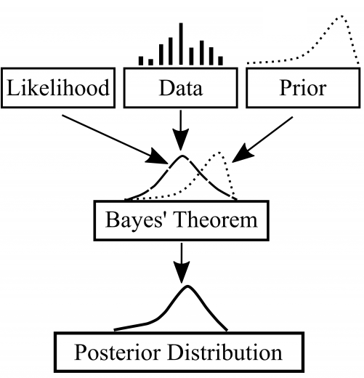

As it is a Bayesian process each iteration, the distribution of the model’s performance in relation to the hyperparameters used is evaluated and a new probability distribution is generated. With this distribution it is possible to make a more appropriate choice of the set of values that we will use so that our algorithm learns in the best possible way.

**CONCLUSION**

* Considering that the COVID-19 disease is global health problem and has affected most countries and their economies, this model focuses on analysing people’s reaction to the pandemic.
* The main goal of the model is to deduce whether the sentiment of the public opinion is positive or negative by applying machine learning algorithms and NLP techniques.
* Even though the analysis found variation of opinions, it seems that people mostly remain positive about the pandemic
* January is the only month in which negative thoughts predominated, March is the month when the COVID-19disease was declared as a pandemic and many countries started to apply care measures and safety protocols, which coincides with the rise of positive thoughts.
* To summarize, 62% of the users showed positive feelings and 38% of the users showed negative feelings.